Connecting to CCI Oracle from SQL Developer

Instructions

Instructions

Once you have requested your CCI Oracle Linux account I suggest testing everything using the terminal first. You can do that using the following command.

ssh jda57@linux.cci.dexel.edu

Replace jda57 with your Drexel abc123 username and use the password you used when you created your CCI Oracle Linux account. That password is NOT the same as your Drexel password (UNLESS that's what set your Oracle password to when you created it).

Once you are logged into the server you can connect to Oracle using sqlplus. Use the following command

sqlplus

When prompted for a username enter jda57@ike
Replace jda57 with your abc 123
When you are prompted for your password enter your password here and then you should see a sql prompt in your terminal.

Another way to connect to oracle is using SQL Developer you can download that here https://www.oracle.com/database/sqldeveloper/

NOTE: You will need to CREATE a free Oracle account in order to download SQL Developer.
We DO NOT recommend using your Drexel password for your Oracle account. We recommend creating a different password to login to the Oracle account.

Once you install sql developer open it up and create a new connection
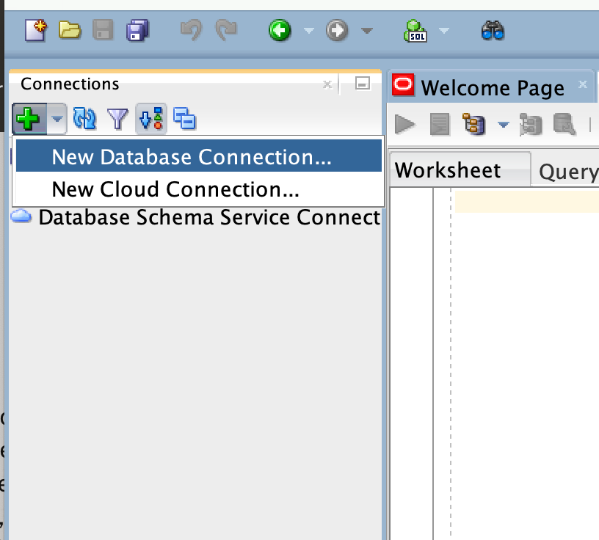

Enter the following information into the prompt.

Name: You can name it whatever you want I used “CCI Oracle”
Database Type: Oracle
Authentication Type: Default
Username: your Drexel abc123 username
Password: The password you use to connect to oracle on the linux server after you type sqlplus.
Connection Type: Basic

Hostname: oracle2.cci.drexel.edu
Port: 1521
SID: orcl
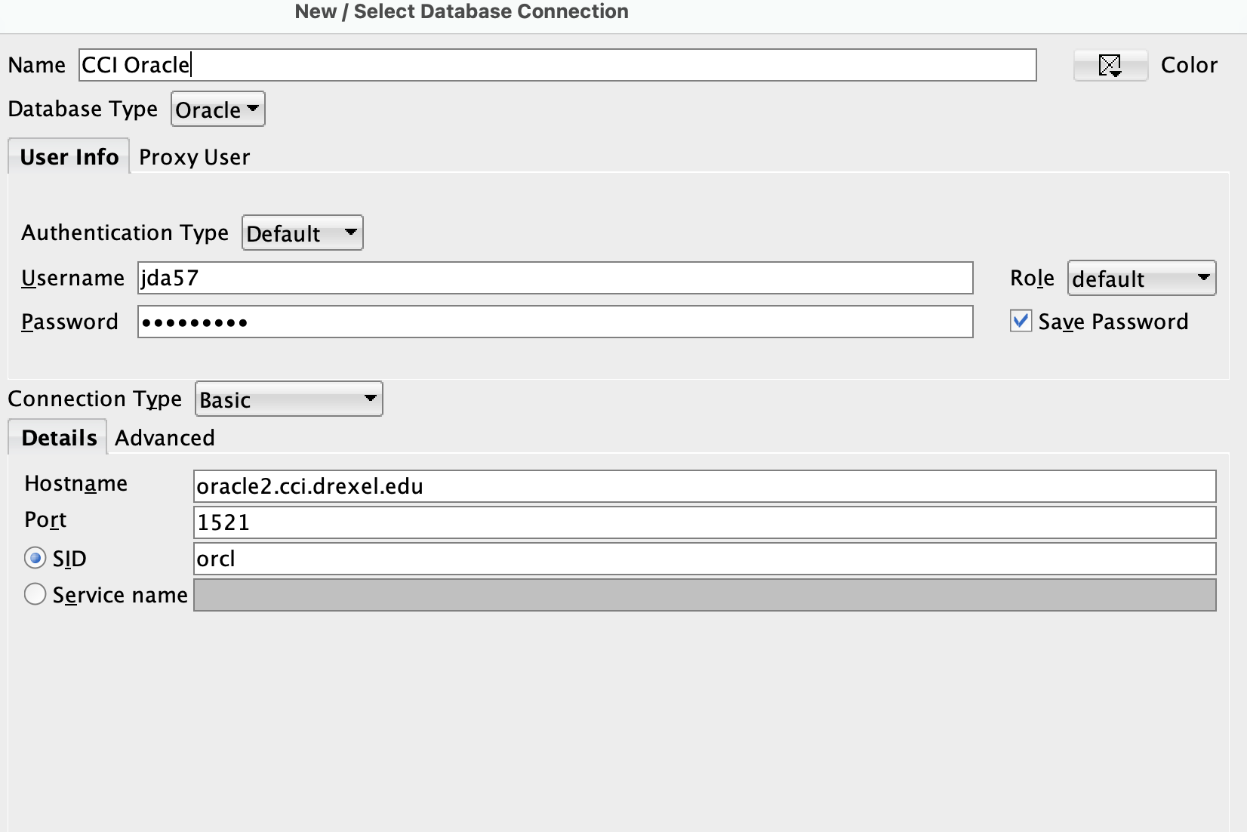

Once you have all of this information entered click test to test it out or connect.

Troubleshooting

If you are not able to connect, I suggest checking the following:
- Make sure you are connected to the internet
- Check your username and password
- Check the spelling of the hostname
- Connect to Drexel VPN

If that fails, review how to ssh to linux.cci.drexel.edu and getting into sqlplus to confirm you have access. AND THEN see if there are other troubleshooting tips at the links below.
- linux.cci.drexel.edu/docs/
- and…
- https://support.cci.drexel.edu/cci-virtual-lab-resources/oracle-or-linux-or-sql-linuxischooldrexeledu/

If get these errors on Windows: "IO Error: The Network Adapter could not establish the connection" and/or "Vender Code 17002” and/or “Status: Failure - Test failed: 10 Error: The Network Adapter could not establish the connection”
- Maximize the screen on this YouTube video below. This solution has been used before in these cases and has worked.
- Note that you may need to try connecting 3-4 times at the end. Don't double-click buttons or options in the GUI that work with single click.
- (26) Oracle Database IO Error: Network Adapter could not establish the connection Vendor code 17002 – YouTube
  - https://www.youtube.com/watch?v=r9pHqOfV2f0

If that fails, and you’re on Windows, it's worth trying the Command Prompt approach at "SOLUTION 2" section at the link below.
- Fixed: 'IO Error: 'Network Adapter couldn't establish the connection' (appuals.com)
  - https://appuals.com/how-to-fix-io-error-the-network-adapter-could-not-establish-the-connection-on-oracle-sql/
If all that fails, and you’re on Windows, try the "SOLUTION 1" section at the link above.

- If all that fails, and you’re on Windows., try the link below where...
you start/restart these 5 listener services....
  - These are the 5 services
    - OracleVssWriter"databasename"
    - OracleService"databasename"
    - OracleOraDb11g_home*TNSListener
    - OracleOraDb11g_home*ClrAgent
    - OracleDBConsole"databasename"
- More details at link below, but scroll down to the solution mentioning the above 5 services.
- java - sqldeveloper error message: Network adapter could not establish the connection error - Stack Overflow
  - https://stackoverflow.com/questions/7025014/sqldeveloper-error-message-network-adapter-could-not-establish-the-connection-e

After that, and you’re on Windows., try the "kill port" command solution (2nd solution from the top) at the link below.
- oracle - What is the cause of this problem "IO Error: The Network Adapter could not establish the connection" on Sql Developer? - Stack Overflow
  - https://stackoverflow.com/questions/58746972/what-is-the-cause-of-this-problem-io-error-the-network-adapter-could-not-estab

And then try the other solutions mentioned both of the stackoverflow pages. Start with the stackoverflow directly above first.

Some of these stackoverflow solutions may not apply to Windows, or may not be feasible for you to apply.

If that all fails, try a complete uninstall and reinstall and re-set-up after that.

If the above suggestions do not help, there's not much more that we can do.

You'll need to do the assignments from command prompt at linux.cci.drexel.edu and/or using sqlplus there.

You can tell your professor and they can reach out to us to discuss further with ihelp@drexel.edu .

But try all the above solutions first.

